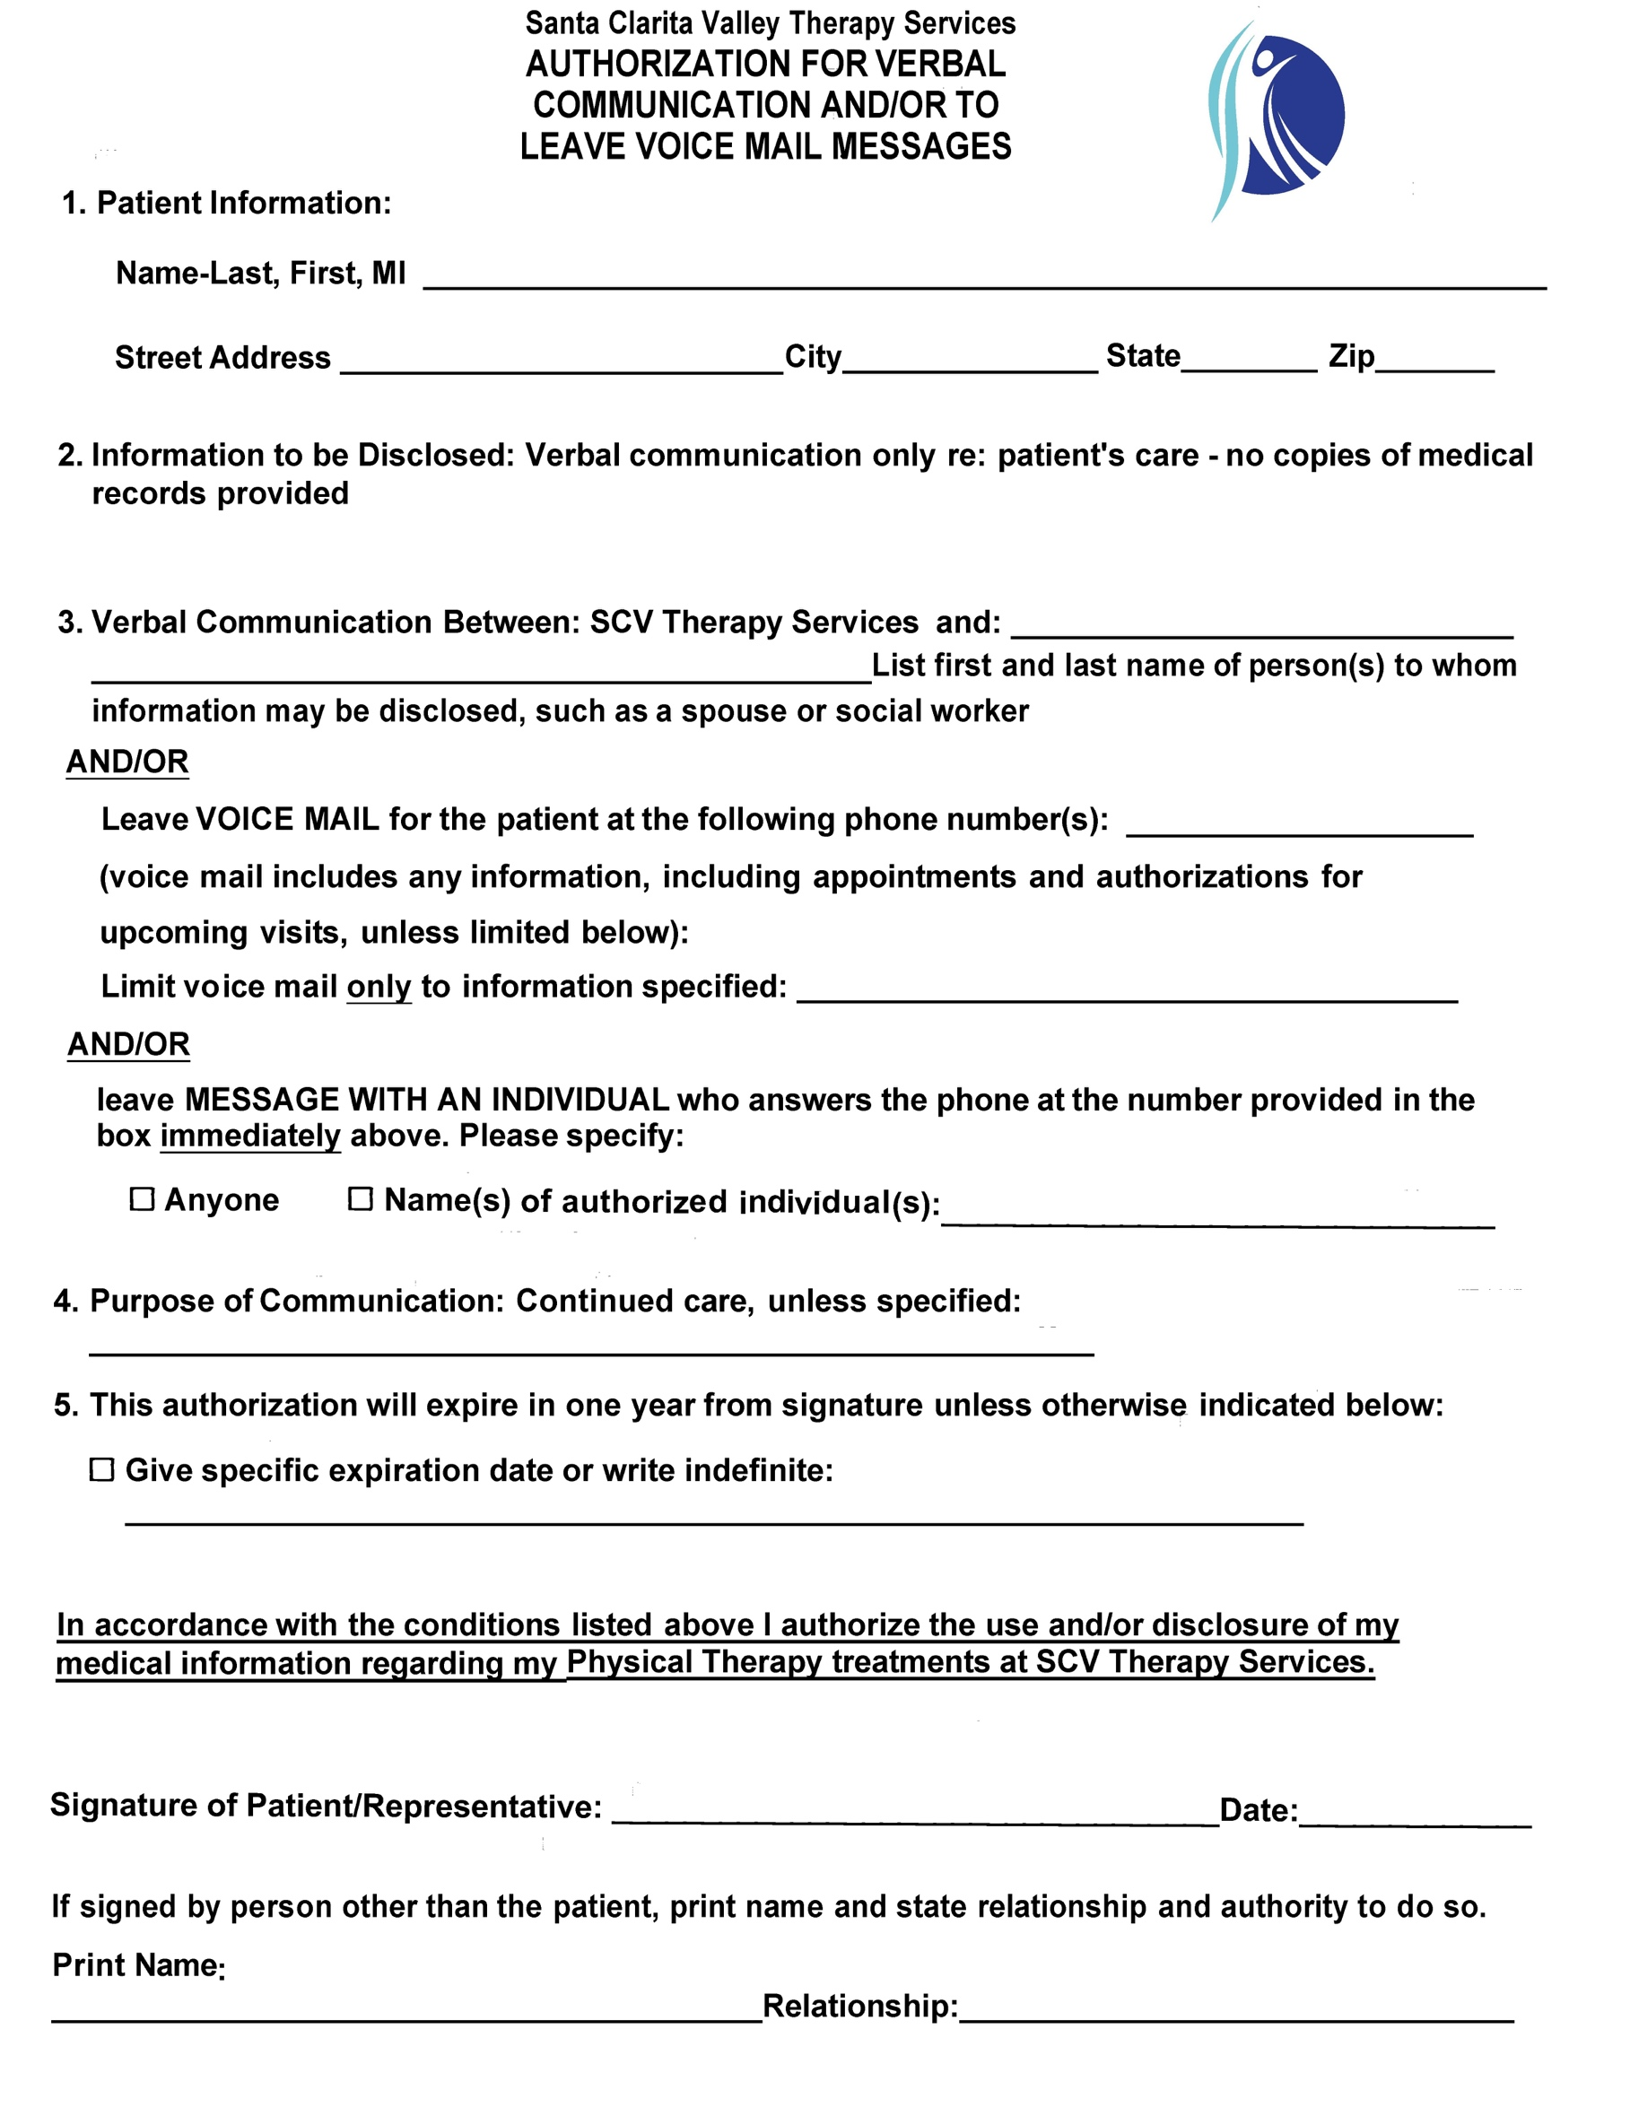
Santa Clarita Valley Therapy Services
Patient Language Assistance Form

Patient Name: Date:
Patient’s Primary Language: English
Spanish
Other (Specify)___________________
Interpreter needs:
- Yes, I am requesting interpretive service for language_______________
- No, I will use my family and/or friends for interpretive services
- Yes, my family or friend is a minor (under age 18)
- No, I do not require interpretive services
- Other: _______________________________________________
Please Note:
You may be able to receive free language assistance services (interpretation and translation) from your Health Insurance/health plan. After completing above information, should your preferences change, please inform this clinic.

Patient Signature: _________________________________________
Date: ___________________________________________________
Santa Clarita Valley Therapy Services

Patient Admission Information

First Name MI Last Name

DOB Marital Status

Address City

State Zip

Home/Cell Phone # Email

Employer Phone #

Emergency Contact Phone #

Referring Physician Phone #

Insurance Information

Primary Insurance

ID# Group#

How did you hear about us? _______________________________________________________
______________________________________________________________________________
Santa Clarita Valley Therapy Services
Financial Policy

Thank you for choosing Santa Clarita Valley Therapy Services as your physical/occupational therapy provider. We are committed to providing the best possible care for you. In order to achieve this goal, we need your assistance in understanding our payment policy. Please understand that payment of your bills is considered part of your treatment. The following is a statement of our Financial Policy. Please read and sign prior to your treatment.
Payment of services is due prior or upon completion of each treatment visit. We accept CASH, VISA, MASTERCARD, DISCOVER, AMEX, and/or PERSONAL CHECKS. Once your complete insurance information is on file, we will be happy to submit your claims to your insurance carrier.
Initials_______
Private Insurance
We will gladly discuss your proposed treatment and answer any questions relating to your insurance company. You must realize, however, that your insurance is a contract between you, your employer, and/or the insurance company. We are not part of your contract. We must emphasize that as your provider, our relationship is with you, and not your insurance company. While filing of insurance claims is a courtesy we extend to our patients, all charges are your responsibility from the date of services rendered.
It is our policy to verify benefits and eligibility to estimate your payment responsibility. However, there is no guarantee from the insurance company of their payment amount. We may not know the exact amount due until the claim has been processed. At that point, there may be more due on your account. In this event, we will mail you a statement, and appreciate your prompt payment.
Regarding insurance plans where we are a participating provider, we will take the contracted rate assigned by the insurance company and make proper adjustments to your claim.
Initials_______
Facey
If you have an authorization from Facey Medical Group and there has been a change within your insurance carrier plan between the valid date of authorization and service date and your claim is denied all charges will be your responsibility during that lapse in coverage. It is the patient’s responsibility to update Facey Medical Group when there has been any change in the members plan. Copayment amounts are determined by your medical plan, you must realize, however, that your insurance is a contract between you, your employer, and/or the insurance company. We are not part of your contract. We must emphasize that as your provider, our relationship is with you, and not your insurance company. While filing of insurance claims is a courtesy we extend to our patients, all charges are your responsibility from the date of services rendered.

Initials_______
Consent to Treatment
CONSENT TO TREATMENT: I consent to rehabilitation and related services at Santa Clarita Valley Therapy Services. In doing so, I understand, acknowledge, and affirm that such rehab and related services may involve bodily contact, touching, and/or direct contact of sensitive nature.
TREATMENT OF MINORS: I, as a parent/guardian of a minor receiving treatment under here, do hereby agree and understand that I have been advised to remain on the premises during any such treatment, and waive any claim I may have resulting from failure to do so.
LIABILITY: I know and agree that Santa Clarita Valley Therapy Services is not responsible for loss or damage to personal valuables.
WAIVER AND RELEASE: I hereby release, discharge and acquit Santa Clarita Valley Therapy Services, its agents, representatives, affiliates, employees, or assigns, of any form and all liability, claim, demand, damage, cause of action, or loss of any kind arising out of or resulting from my refusal to accept, receive or allow emergency and or medical services, including but not limited to ambulance service, emergency medical technician, physical or urgent care services.
AUTHORIZATION OF PAYMENT: I hereby assign all benefits directly to Santa Clarita Valley Therapy Services and also authorize release of any medical records necessary to facilitate my treatment to process medical claims and as otherwise permitted or required in the Notice of Privacy Practices. I understand fully that in the event my insurance company or financially responsible party does not pay for the services I receive, I will be responsible for payment.
Initials_______

Santa Clarita Valley Therapy Services
Missed Appointment and Cancellation Notice Policy

Sessions that are scheduled in advance are reserved exclusively for the client. When a session is cancelled without adequate notice, the therapist is unable to fill this time slot by offering it to another “wait listed” client. SCV Therapy is also unable to bill your insurance company for sessions that are not kept.
Please note, a fee of $45 will be charged when a client misses or cancels an appointment without giving 24 hours notice. This means that if an appointment is scheduled for 3 pm on a day, notice must be given by 3 PM the previous day. You can cancel your appointment by calling SCV Therapy at 661-284-1984 or emailing us at SCVTherapy@gmail.com. Do not reply to text or email reminders, these are automatic and do not receive responses. NO fee will be assessed if we receive appropriate notice.
Missed appointment fees will be automatically charged to the credit card on file, following a 24-hour grace period from the date of the scheduled appointment. This 24 hour grace period allows the client to be able to get in touch with SCV Therapy to discuss the reason for the missed appointment. During the grace period, the client can choose to pay the fee with another form of payment other than the credit card on file or if necessary, set up a payment plan. If the client does not contact SCV Therapy to make other payment arrangements within 24 hours, the credit card on file will be charged. IF PAYMENT FOR THE MISSED APPOINTMENT HAS NOT BEEN SATISFIED, ALL FUTURE APPOINTMENTS ON THE CALENDAR WILL BE CANCELLED AND ALL FUTURE VISITS WILL BE BOOKED VIA OUR SAME DAY APPOINTMENT SCHEDULING FEATURE (see below). We’ll do everything possible to respect your time. Please respect ours!
SAME DAY APPOINTMENT SCHEDULING
Some of our clients have circumstances that make it difficult for them to adhere to a planned schedule. Because of this, we have created a Same Day Appointment Scheduling feature. Call us the evening before or the day that you would like to be seen, and we’ll try our best to get you on the schedule. At the worse, we’ll waitlist you and get back to you if a time becomes available. Please understand that though your treatment plan will remain unchanged, utilizing this feature means that specific treatment times and doctor availability will be variable.
I have read and fully understand my responsibility to advise SCV Therapy of any cancellation within 24 hours. I accept this policy and authorize SCV Therapy to charge my credit card on file $45 in the event that I fail to follow this procedure.

Patient’s Name: ______________________________________

Signature: ________________________Date: ______________
Santa Clarita Valley Therapy Services
Notice of Privacy Practices

Santa Clarita Valley Therapy Services understands the importance of protecting your healthcare information. Under the guidelines of the Health Insurance Portability and Accountability Act of 1996, we have established the following practices to ensure the security of your healthcare records.

ADMINISTRATIVE REQUIREMENTS
- All staff, students, and volunteers will receive job-specific training regarding the Privacy Rule upon hire and as necessary.
- All staff, students, and volunteers will be on a "need to know" basis. No one in the organization will have access to protected healthcare information unless they need it to do their job. If they do need access, it will be limited to the "minimum necessary" to allow completion of their job function.
- Enforce employee sanctions as necessary.

TECHNICAL REQUIREMENTS
- Automatic logoffs on all computers where protected healthcare information is used.
- Passwords to all computers where protected healthcare information is maintained are changed every 30 days.
- Software contains "firewall" and "Routers."
- Software vendors have restricted access to data files that is customized to their needs to be able to service our computer systems.
- No unauthorized computer programs are to be installed.

PHYSICAL REQUIREMENTS
- All copiers, fax machines, and computer screens are in secured locations to limit access to visitors and vendors.
- All fax cover sheets will include a disclaimer regarding an unauthorized disclosure of protected healthcare information.
- All medical records are to be contained in a locking metal cabinet.
- Conversations containing protected health information are not to be held in public places.
- Protected healthcare information will not be unattended at any time.
- All staff, students, and volunteers will refrain from engaging in any conversation about a patient that is not necessary for treatment.
- All staff that is required to travel with protected healthcare information will maintain these records in locked container.
- All protected healthcare information no longer needed for services or maintenance purposes are to be shredded before disposed.

PATIENT AUTHORIZATION

Disclosures can only be made for the purpose of health care operations to another covered entity that has a previously established relationship with the patient.

You must obtain a signed authorization from a patient for the following:
- Marketing of any kind.
- Fundraising on another organization's behalf.
- Any use or disclosure of psychotherapy notes.
- Coordination of benefits on fully paid claims.
- New healthcare providers outside your organization.
- Any other entity that requests protected healthcare information.

SANCATIONS & NON-RETALIATION POLICY

Santa Clarita Valley Therapy Services will take all reasonable steps to mitigate and/or minimize the damage caused by privacy breach. Santa Clarita Valley Therapy Services does pledge not to retaliate in any way against anyone who reports a violation or participation in an investigation of violation.

Sanctions will be determined appropriately depending on the severity of the violation.

REPORTING A SUSPECTED PRIVACY VIOLATION

Any person who believes that a privacy violation has occurred can contact the Privacy Officer, either by phone or in writing. All reports will be investigated promptly and documented with imposed sanctions if violation is verified.

Privacy Officer: Elia Gris, P.T.

25129 The Old Road, Suite 100

Santa Clarita, CA 91381

(661) 284-1984

_____________________________________________________________________________________________________________

I have read and understand Santa Clarita Valley Therapy Services' NOTICE OF PRIVACY PRACTICE

Signature: _______________________________ Date: __________________

Santa Clarita Valley Therapy Services
Patient Assessment – Medical History

Patient Name: Date of Birth:

Occupation:
Height: Weight:

History of Present Condition
Please describe the problem that brings you here today: ____________________________________________________________________________________________________________________________________________________________
When did your present symptoms start? _____________________________________________
How? (gradually, suddenly, injury) _________________________________________________
What makes your symptoms better? ________________________________________________
What makes your symptoms worse? ________________________________________________
Have you had surgery related to this injury? Yes / No
If yes, when and what type? _________________________________________________
Please indicate where your symptoms are located:
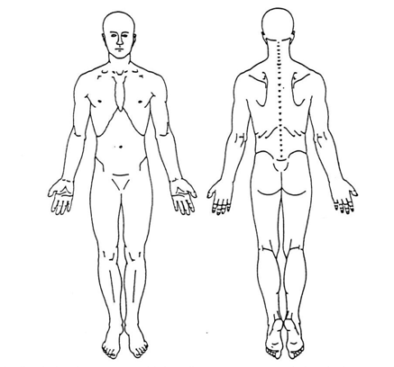
On the scale below please circle the number that best represents your level of pain:
(Circle one) 0 1 2 3 4 5 6 7 8 9 10
No pain Worst pain

Please describe the quality of your symptoms (numbness/tingling, sharp, achy, weakness, etc.):
______________________________________________________________________________
______________________________________________________________________________
Santa Clarita Valley Therapy Services
Patient Assessment – Medical History Cont.

What treatments have you received for this problem so far? ______________________________________________________________________________
Have you had an x-ray, MRI, or any other testing for this problem? __Yes __No
If yes, when and what type? ______________________________________________________________________________
Are you presently taking any medications? __Yes __No
If yes, please list: ____________________________________________________________________________________________________________________________________________________________
What specific activities are you having difficulties with? (i.e. housework, dressing etc.)
______________________________________________________________________________
Do you participate in any sports, exercise, or engage in strenuous activities on a regular basis?
If yes, please describe:
______________________________________________________________________________
What are your specific goals for therapy?
______________________________________________________________________________

Please check if you have or have had any of the following:
__Alzheimer’s __Huntington’s
__Cardiovascular Disease __Immunosuppression
__Cauda Equina Syndrome __Lupus
__Cerebral Vascular Accident __Muscular Dystrophy
__Current Infection __Obesity
__Diabetes Mellitus Type 1 __Osteoarthritis
__Diabetes Mellitus Type 2 __Parkinson’s
__Fibromyalgia __Rheumatoid Arthritis
__Fracture or Suspected fracture __Traumatic Brain Injury
__High Blood Pressure Other: ___________________________
__History of Cancer, if yes please indicate below:
Type: ____________________________
How Long: _______________________

Is there any other information regarding your past medical history that we should know about?
____________________________________________________________________________________________________________________

